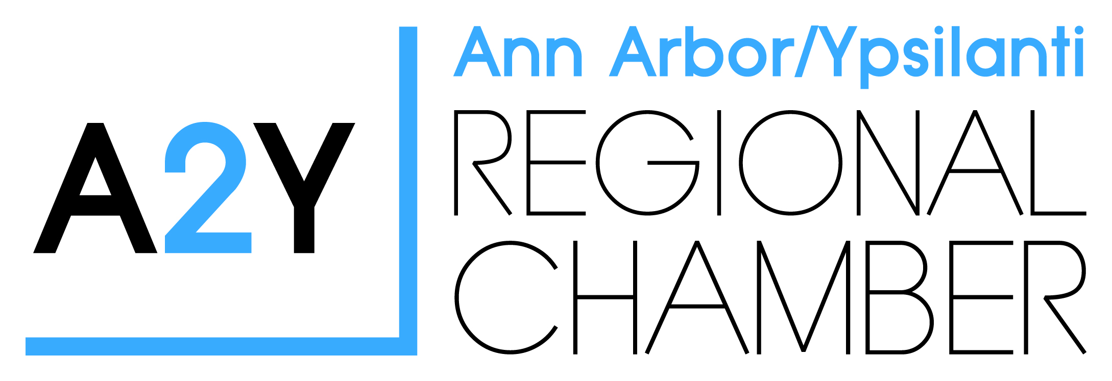
2017 E³ Award for Teacher of the Year
The Teacher of the Year Program recognizes the great contribution teachers make in Washtenaw County and to the learning community. This award recognizes and honors teacher excellence. It does not attempt to select the “best” teacher; rather, to identify, from among many outstanding teachers, one teacher to serve as a visible and vocal representative of what is best in the profession.
The 2017 E³ Award for Teacher of the Year in Washtenaw County will meet the following criteria:
Must be a certified teacher
Is an exceptionally dedicated, knowledgeable, and skilled educator in a Washtenaw County school, pre-kindergarten through grade 12 and alternative education;
Plans to continue in an active teaching status;
Spends a minimum of 50% of her/his time teaching students;
Inspires students of all backgrounds and abilities to learn;
Has the respect and admiration of students, parents, and colleagues;
Serves an active role in the community, as well as in the school district;
Must be in good standing with her/his district; and
Has completed a minimum of five years of successful teaching experience

NOMINATIONS:
Colleagues, administrators, board members, parents, students, education-related organizations, such as PTO’s, and other community members may submit nominations for teachers who meet all the criteria listed above. Nominations must include a written recommendation describing:
- The teacher;
- The nominators professional relationship with the teacher; and
- How the teacher addresses each criterion listed above. (This must contain significant detail.)
The nomination must also include:
- Letters of recommendation from students, parents and colleagues;
- Pictures or videos of events where the teacher had significant impact;
- Copies of publicity the teacher may have received;
- Additional supporting evidence the nominator feels supports the nomination
The nomination deadline is Thursday, March 30th by 4:30 p.m.

2017 E³ Award for Teacher of the Year Application
Teacher’s Name: ___________________________________________________________
Email Address: _________________________Phone #:____________________________
School Name: _____________________________________________________________
District Name: ____________________________________________________________
Major Subject Area(s) (if any) ______________________________ Grade Level(s):_____
Total Years of Teaching Experience: ______ Years in Present Position: _______
Teacher Certification Number: ___________________________________________
Teacher’s Signature: ___________________________________________________
Nominator’s Name: ___________________________________________________
Email Address: _________________________ Phone #: ______________________
====================================================================================

School Principal
I hereby acknowledge that this applicant, with my approval, is submitting a 2017 E3 Award for Teacher of the Year Application.
Principal Name: __________________________________________________________
Signature: _________________________________ Title: ____________ Date: ________
School Name: ________________________ District: ______________________________
Email Address: _______________________ Phone: _______________________________

Please return to Barbara Davenport at Barbara@a2ychamber.org, 734.214.0104, 2010 Hogback,
Suite 4, Ann Arbor, MI 48105 by Thursday, March 30th by 4:30pm.

