The Flowers will be dropped off early at the site indicated on Saturday, May 20, 2017

Each site can request up to $50 worth of plants in any combination they desire, provided FREE through Ypsi Proud. Should you want more than $50 worth, you will be asked to pay the difference upon checkout. All flowers provided by Garden Fantasy Florist (www.gardentantasyflorist.com) Please submit your site choices by Thursday, May 11, 2017
Please return this form via fax 734.665.4191 or email YPSIPRIDE@a2ychamber.org.

Site Name ________________________________ Site Captain __________________________________________
Please also indicate here how much soil/ mulch will you need for your site, if necessary:
Soil______________________ Mulch______________________

Perennials
Perennials are sold as a single plant. Please keep in mind that they will continue to grow and expand year after year. Each site can choose up to 4 different containers of perennials for their site, free of charge.
Quantity  _______ | Astemisia (Silver Mound) Ground Cover Sedum  Likes full sun; grows to about 10’’ | 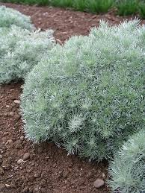 | Quantity  _______ | Dragon’s Blood Ground Cover Sedum  Likes full sun; grows to about 5’’ | 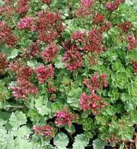
_______ | Hosta  Likes partial shade; heights vary | 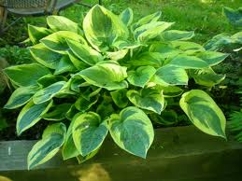 | _______ | Yarrow  Likes full sun | 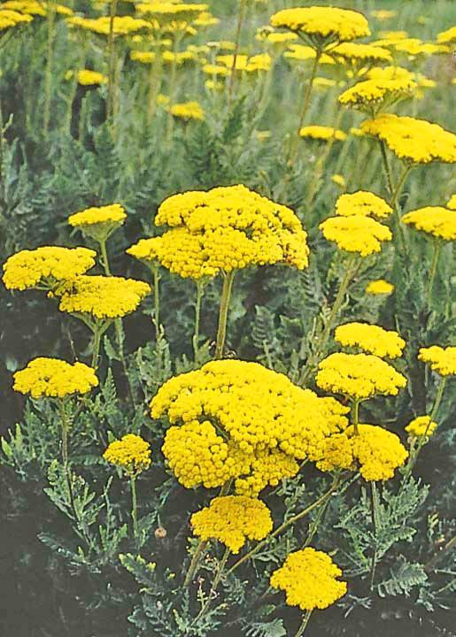
_______ | Rudbeckia (Blackeyed Susan)  Likes full sun | 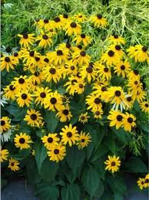 | _______ | Tall Garden Phlox  Likes full sun | 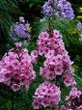
_______ | Nepeta (Walker’s Low) (Cat Mint)  Likes full sun; grows to about 18’’ | 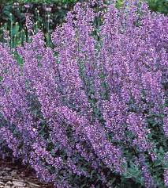 | _______ | Astilbe  Tolerates shade | 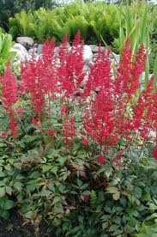

Annuals
Each site can choose up to 2 different flats of annuals for their site, free of charge. There are 48 plants per flat, unless otherwise indicated, and you can choose either an entire flat or half a flat (.5, 1, etc.). Please enter how many flats you’d like for each flower type.

Quantity  _______ | Portulaca/ Moss Rose  Likes sun  Mixed | 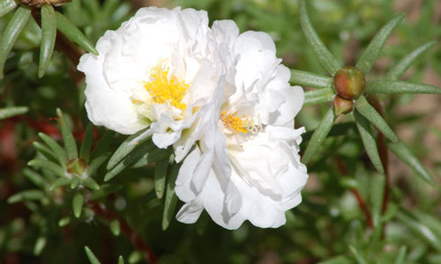 | Quantity  _______ | Profusion Zinnia  Mixed  18 plants | 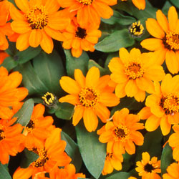
_______ | Dahlia  Likes sun  Mixed  18 plants | 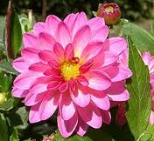 | _______ | Petunias  Likes sun  Mixed  White, red, pink or purple | 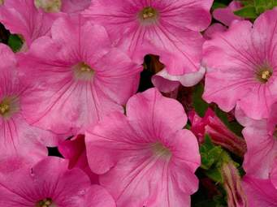
_______ | Blue Ageratum  Sun or partial shade | 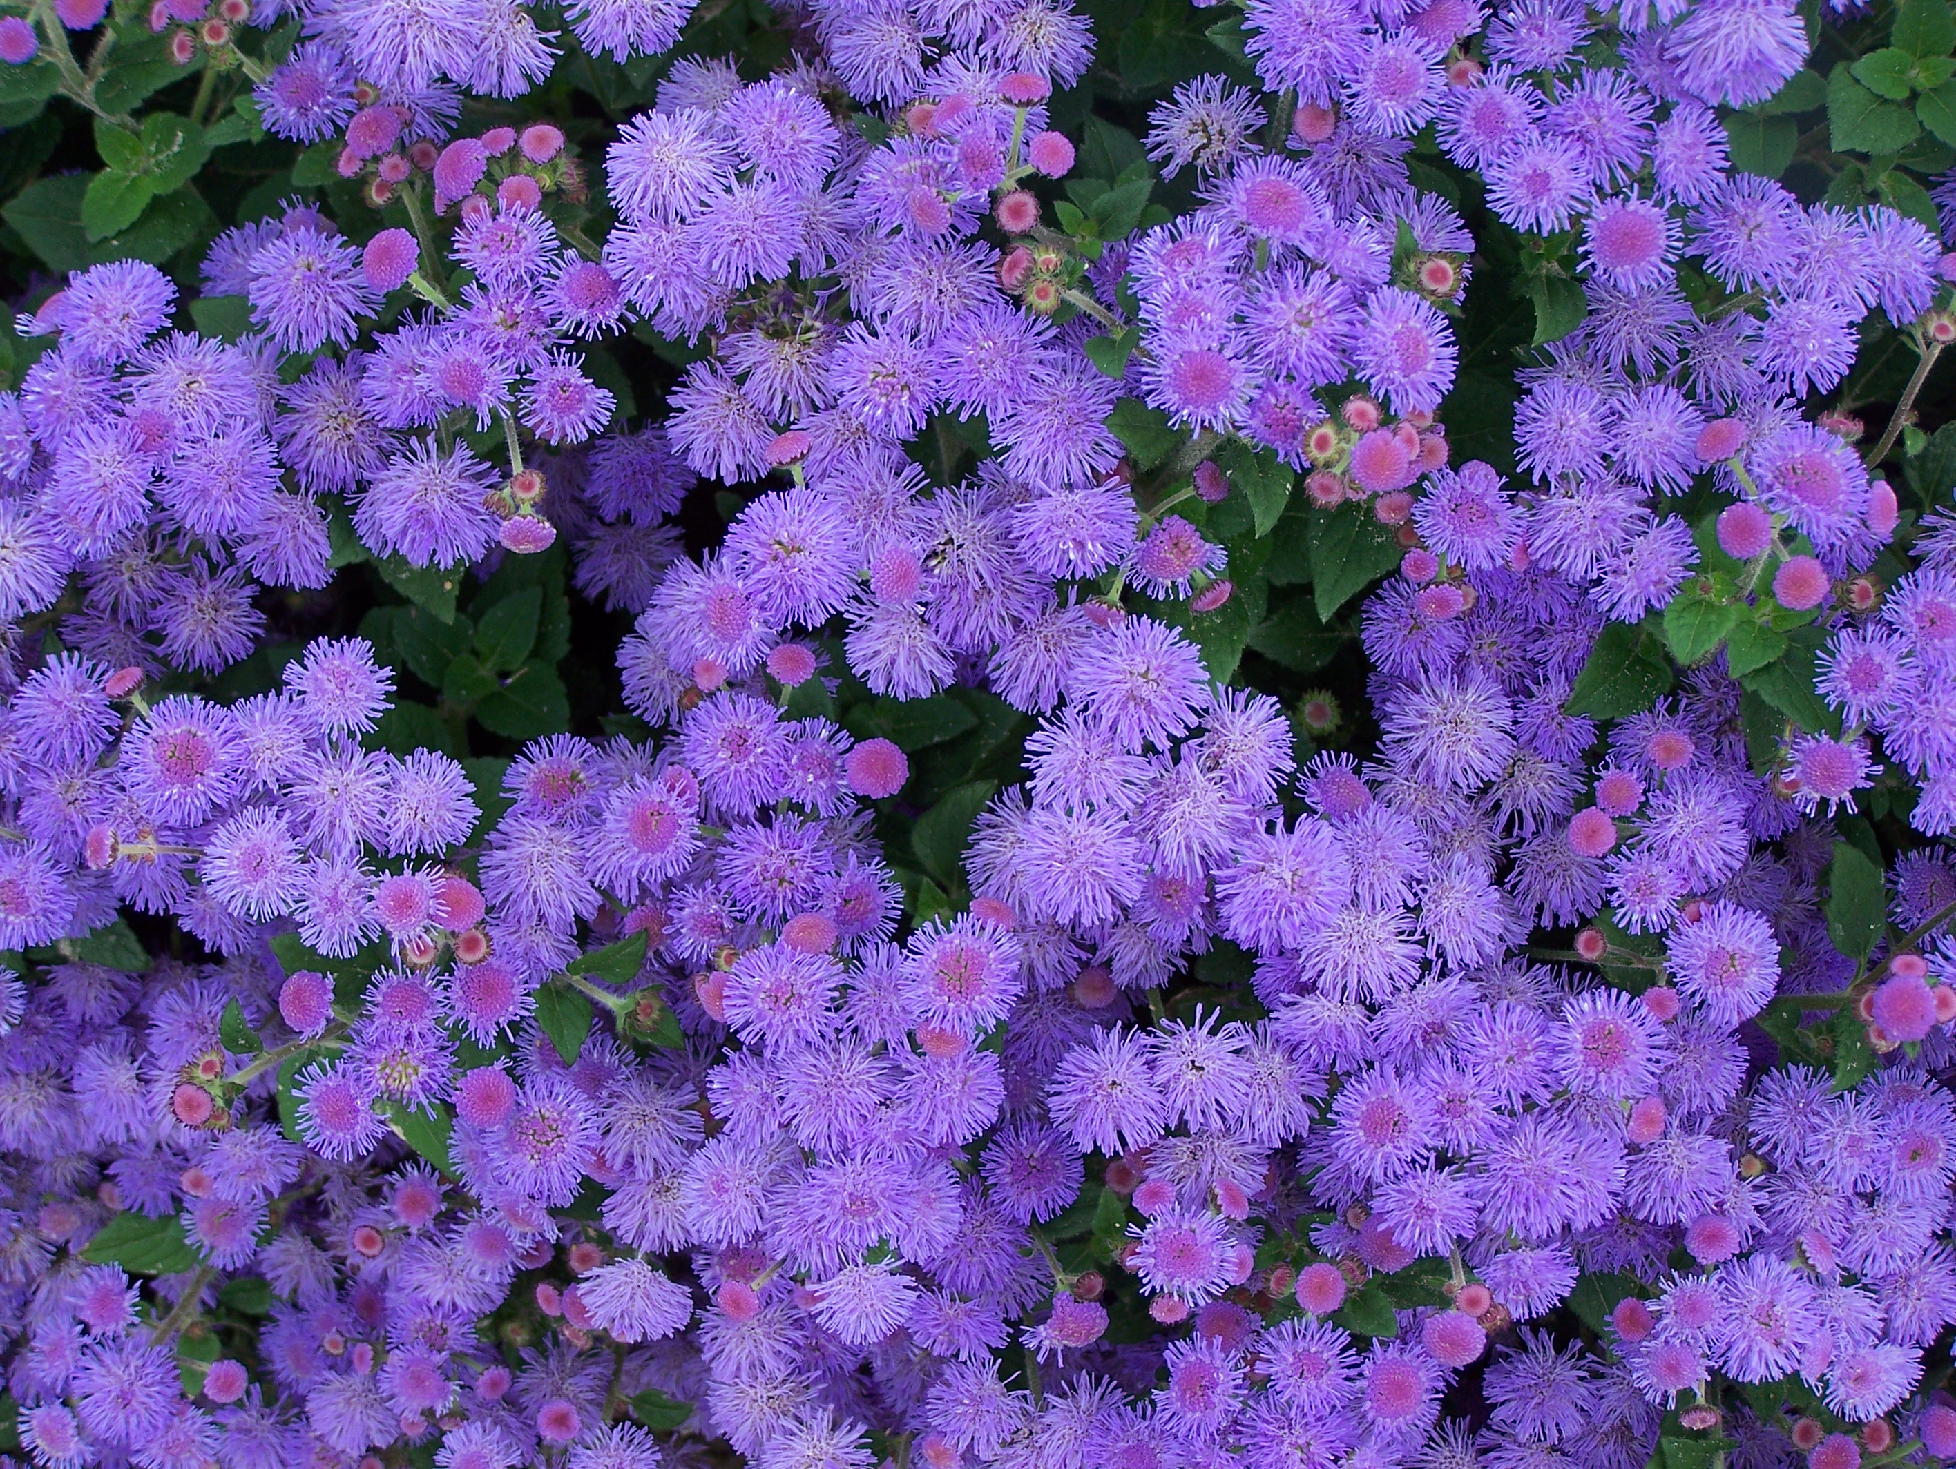
_______ | Begonia (Cocktail mix, red leaf)  Likes full sun | 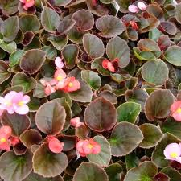
_______ | Marigolds  Likes sun  Mixed, orange or yellow | 

