Ryan Anderson  Clarity Financial Advisors | Jon Bahr  Concordia University | Lisa Barry  WEMU 89.1  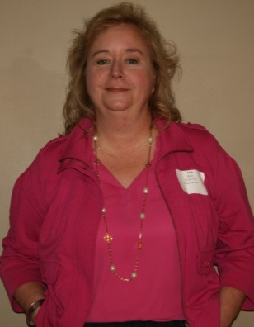 | Jessica Black  City of Ann Arbor
Weneshia Brand  A2 Housing Commission | Alan Burg  Kiwanis Club of Ann Arbor | Shawn Burgdorf  DTE Energy | Kirsten Carr  Junior League of Ann Arbor
Vince Cavataio  EMU Foundation | Debra Christein  B2B CFO | Hiram Clemons  UofM Credit Union | Amy Curtis  UofM Credit Union
Kevin Darrow  Clarity Financial Advisors | Mike Dergis  The Hunter Group | Bobby Downey  KeyBank | Susan Edwards  FirstMerit Bank

Andrew Fink, III  Fink & Valvo, PLLC | Tavi Finn, Weidmayer, Schneider & Raham, CPAs P.C. | Tina Fix  Midwestern Consulting | Amy Freundl  Reinhart Commercial
Cheryl Gong  Logic Solutions, Inc. | Kathy Grant  Community Alliance | Jamie Guise  Old National Bank | Karen Healy  Our House N.P.O.
Tina Heusel  Kemner Iott Benz | Sara Higgins  City of Ann Arbor | Kimberly Hurns  Washtenaw Community College | Rochelle Jones  A2Y Chamber
Linda Kaddouh  UofM Credit Union | Margaret Kephart  Retirement Income Solutions, Inc | Lucas Langdon  Eastern Michigan University | Jen Latham  City of Ann Arbor

Molly Leonard  Sensei Change Associates | Kristi Lin  Rehmann | Wayne Millette  Back Office Studio | Mike Musto  Adams Outdoor Advertising
Gail Nicklowitz  GN Communications | Mike Pettigrew  City of Ann Arbor  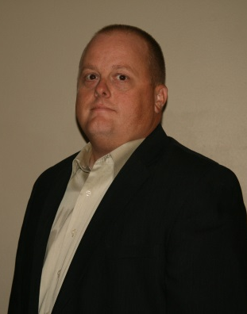 | Connie Pulcipher  City of Ann Arbor | Amanda Reel  United Way of Washtenaw County
Julia Roberts  AAA Transportation Authority | Lori Roddy  Neutral Zone | Jenna Romain  Yeo & Yeo, CPAs | Tom Shewchuk  City of Ann Arbor
Kyra Sims  Legacy Law Center, PLLC  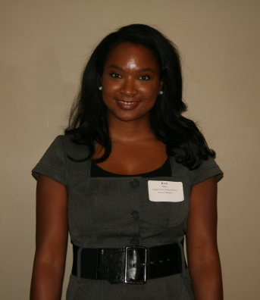 | Angela Sloan  AAA Sloan Insurance Agency | Ken Sprinkles  University Bank | Yvette Washington  AAA Transportation Authority

Roger Williams  Hylant | Mark Wishka  Clarity Financial Advisors
