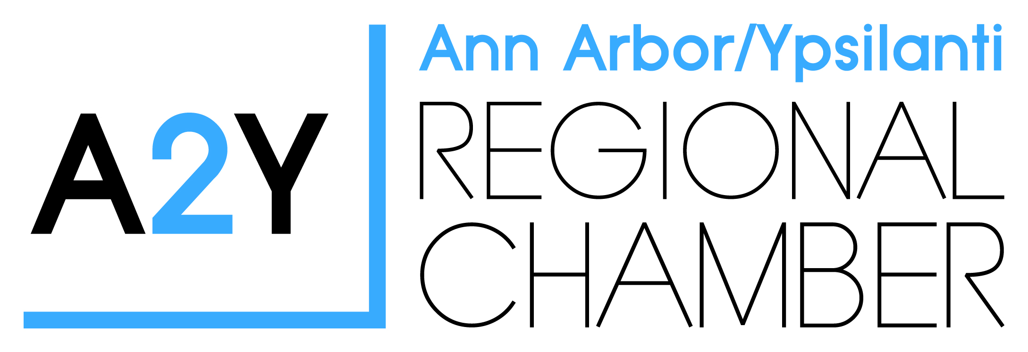

A2Y Chamber presents the
2018 LaFontaine Teacher of the Year

The Teacher of the Year Program recognizes the great contribution teachers make in Washtenaw County and to the learning community. This award recognizes and honors teacher excellence. It does not attempt to select the “best” teacher; rather, to identify, from among many outstanding teachers, one teacher to serve as a visible and vocal representative of what is best in the profession.
The LaFontaine Family wishes to honor the amazing teachers with Washtenaw County and recognize them for their hard work and efforts they put in every single school year.
The 2018 Teacher of the Year Award in Washtenaw County will meet the following criteria:
Must be a certified teacher
Is an exceptionally dedicated, knowledgeable, and skilled educator in a Washtenaw County public
school, pre-kindergarten through grade 12 and alternative education;
Plans to continue in an active teaching status;
Spends a minimum of 50% of her/his time teaching students;
Inspires students of all backgrounds and abilities to learn;
Has the respect and admiration of students, parents, and colleagues;
Serves an active role in the community, as well as in the school district;
Must be in good standing with her/his district; and
Has completed a minimum of five years of successful teaching experience
NOMINATIONS:
Colleagues, administrators, board members, parents, students, education-related organizations, such as PTO’s, and other community members may submit nominations for teachers who meet all the criteria listed above. Nominations must include a written recommendation describing:
- The teacher;
- The nominators professional relationship with the teacher; and
- How the teacher addresses each criterion listed above. (This must contain significant detail.)
The nomination must also include:
- Letters of recommendation from students, parents and colleagues;
- Pictures or videos of events where the teacher had significant impact;
- Copies of publicity the teacher may have received;
- Additional supporting evidence the nominator feels supports the nomination
The nomination deadline is Thursday, February 22, 2018 by 4:30 p.m.
2018 LaFontaine Teacher of the Year Application
Teacher’s Name: ___________________________________________________________
Email Address: _________________________Phone #:____________________________
School Name: _____________________________________________________________
District Name: ____________________________________________________________
Major Subject Area(s) (if any) ______________________________ Grade Level(s):_____
Total Years of Teaching Experience: ______ Years in Present Position: _______
Teacher Certification Number: ___________________________________________
Nominator’s Name: ___________________________________________________
Email Address: _________________________ Phone #: ______________________
====================================================================================
School Principal
I hereby acknowledge that this applicant, with my approval, is submitting a 2018 Teacher of the Year Application.
Principal Name: __________________________________________________________
Signature: _________________________________ Title: ____________ Date: ________
School Name: ________________________ District: ______________________________
Email Address: _______________________ Phone: _______________________________
Please return to Barbara Davenport at Barbara@a2ychamber.org, 734.214.0104, 2010 Hogback,
Suite 4, Ann Arbor, MI 48105 by Thursday, February 22, 2018 by 4:30pm.
The first-place winner will receive a 2-year lease or a $5,000 cash award; the second-place winner (Distinguished Teacher) will receive a $1,000* cash award, and the third-place winner (Commendable Teacher) a $500* cash award.
* Awards for second and third place will be made payable to the school/district where the nominated educator is teaching during the 2017-18 school year. Award funds must be used for educational purposes or project supplies within the classroom.

