Development | Access | Influence
The unique quality of life we enjoy in the Ann Arbor / Ypsilanti area is a result of strong leaders and responsible citizens. Leadership A2Y, offered by the Ann Arbor / Ypsilanti Regional Chamber, presents a rare opportunity for individuals to develop their leadership strengths, gain direct access to local movers and shakers, and define their roles as true stewards of the community.

Development
Strong curriculum and local focus provide Leadership A2Y participants an appreciation of the complex issues facing the Ann Arbor / Ypsilanti area, and the skills to address those concerns. Individualized programming helps you identify the leadership qualities you already possess, and encourages you to enhance your natural strengths. Dynamic workshops address the capabilities neces- sary for effective communication, such as inquiry, dialog and listening techniques. Real-world projects enable collaboration, allowing you to cultivate valu- able relationships with classmates and community organizations in need.

Access
Representatives from business, nonprofit, government and education sectors, as well as the community-at-large, make up each class. Participants have included small business owners, financial institution representatives, public servants, attorneys, executives, university managers and administrators.

Not only will your commitment allow you close interaction with this diverse population, but you will have access to the eyes and ears of influential local experts while investigating a broad range of topics including economic development, community services, health care, education, government, law enforcement and quality of life.

Influence
Leadership A2Y’s 9 month curriculum delivers knowl- edge critical to enhancing your professional career and your role as a community leader. Beginning at the vital two-day retreat, you will develop a broad network of relationships that carry on long after the program ends. Combining your improved leader- ship skills with your new associations will allow you to better represent your business, responsibly serve a deserving non-profit organization and be an energetic steward of your community.

Are You a Leadership Candidate?
Leadership A2Y is open to individuals who work or reside in the greater Ann Arbor / Ypsilanti area. Current and emerging leaders within organizations and individuals interested in serving the commu- nity in a leadership role are encouraged to apply. Orientation is in early October, followed by a retreat in late October. Thereafter, the class meets the second Wednesday of each month, culminating in a June graduation. Class size is limited to the 55 participants with the most outstanding applications. The Chamber accepts submissions January through September. Candidates are generally sponsored by their employers or funded individually. A limited number of scholarships are available, with preference given to nonprofit organi- zations. Demonstrate confidence in key employees by making this investment in their professional growth!

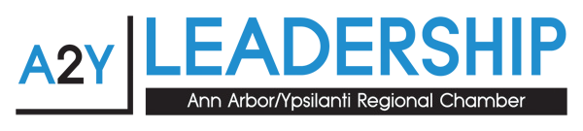

Applications, program information, costs and a class schedule are available at www.a2ychamber.org
or by contacting Barbara Davenport at 734.214.0104 or barbara@a2ychamber.org

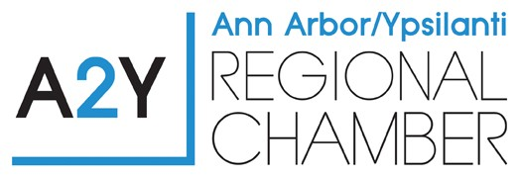
Class Schedule 2018- 2019
Most days run from 8:30am – 5:00pm

Orientation – October 3, 2018, 3pm-5pm
Purpose: Introductions – class members and program. Class photos will be taken.

Impact 2018– October 12, 2018, half day, morning through lunch
Purpose: Educational half-day forum on current community issues.

Retreat - October 25 & 26, 2018, Weber’s Inn, Ann Arbor (overnight stay optional)
Purpose: Assessing and developing leadership. Understanding what we bring to the party of community leaders. Connecting with your classmates.

Economic Development Day - November 14, 2018
Purpose: Where is the economic growth engine? Government, Academic and Community impact on economic growth.

Community Services/Non-Profit Day - December 12, 2018
Purpose: Discover the resources available in our community. Where are the gaps? What are the volunteer opportunities that are available?

Health Care Day - January 9, 2019
Purpose: Health Care services delivery – challenges and successes.

Education Day - February 13, 2019
Purpose: How are we preparing tomorrow’s workforce?

Local Government - March 13, 2019
Purpose: Understanding governmental levels and how their decisions impact our basic services.

Justice Day- April 10, 2019
Purpose: From breaking the law, to incarceration, to release or rehabilitation.

Quality of Life Day – May 8, 2019
Purpose: Quality of Life is different for each individual. Understanding the importance of rich community offerings that range from arts and cultural activities to museums and recreation and sports.

Graduation Day - June 12, 2019
Purpose: Certified Tourism Ambassador™ training, celebration, closure and feedback.

