The A2Y Regional Chamber is seeking nominations for exemplary educational endeavors taking place in the area public schools. One E³ Award trophy and a cash award (provided by a local community partner and the Foundation of the Ann Arbor/Ypsilanti Regional Chamber) will be given in each of these school districts for an exemplary program:
- Ann Arbor Public Schools
- Lincoln Consolidated Schools
- Ypsilanti Community Schools
- Out County District (One shared award for Chelsea School District, Dexter Community Schools, Manchester Community Schools, Milan Area Schools, Saline Area Schools, Whitmore Lake Public Schools, and Washtenaw Intermediate School District)

Award recipients will also be recognized at the A2Y Chamber’s Annual Awards Breakfast at Weber’s on April 17, 2019.

E³ Program Awardees in Washtenaw County will meet the following criteria:
- Programs must have been in operation between May 2018 and February 2019.
- Be exemplary: Something that serves as a model, deserving imitation.
- Be an endeavor: An activity directed toward a goal.
- Provides enhanced educational opportunities and experiences for students both inside and outside the classroom.
- Increases parental and/or community involvement in the educational process.
- Prepares students to enter the workforce and develop lifelong learning skills.
- Develops innovative initiatives, business partnerships, or career pathways.
- Continues to improve the quality of area public school districts.

Nomination Procedure:
Colleagues, administrators, board members, parents, students, education-related organizations, such as PTOs, and other community members may submit nominations for programs who meet all the criteria listed above. The Nomination form and a helpful checklist can be found at a2ychamber.org.

Nominations must include a written recommendation describing:
- The activity, effort, or program that is being nominated, including the length of time it has been in place and the number of students impacted.
- Detail of how the group activity, effort, or program addresses each of the criteria above established for the E³ Award.
- A photo that represents the program is required.

Optional:
- Copies of publicity received, additional letters of recommendation, pictures or videos of events conducted, etc., are not necessary, but will help the selection committee.

The nomination deadline is Thursday, February 21, 2019 by 4:30 p.m.
Nomination Form

Program Being Nominated: _________________________________________________________
Email Address: ___________________________________ Phone #:________________________
School District: __________________________________________________________________
School Building Name: _____________________________________________________________
Nominator’s Name: _______________________________________________________________
Nominator’s Email: _______________________________________________________________
Nominator’s Phone #: _____________________________________________________________
How did you hear about the E3 Awards? (Circle) Mail A2Y Chamber Website Newsletter Word of Mouth Email Other: ___________________
Please return this nomination form, your written recommendation, a program photo, and any other supporting materials to Barbara Davenport by Thursday, February 21, 2019 by 4:30 p.m.:
Email at Barbara@a2ychamber.org; Fax to (734) 665-4191; Mail to 2010 Hogback, Suite 4, Ann Arbor, MI 48105; or call (734) 214-0104 to make other arrangements.

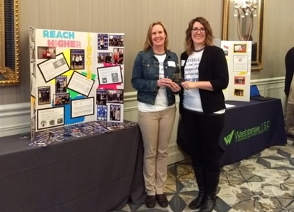
Past E³ Award Recipients Include:
- 2018:
  - Ann Arbor: I Got You! At Carpenter Elementary School
  - Lincoln: Reach Higher Program at Lincoln High School
  - Ypsilanti: The Leader in Me at Erikson Elementary School
  - Out County: Cultural Arts Program at the Washtenaw Intermediate School District
- 2017:
Lincoln High School - Reach Higher Program
  - Ann Arbor: Project Lead the Way at Huron High School
  - Lincoln: Project Green at Bishop Elementary School
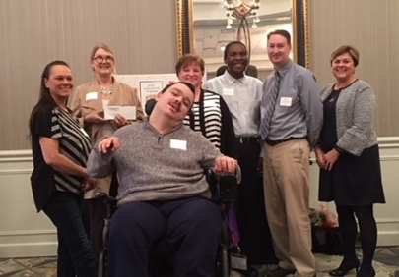
  - Ypsilanti: Student Development Program at Ypsilanti Community High School
  - Out County: Video News Production at the South and West Washtenaw Consortium
- 2016:
  - Ann Arbor: Ann Arbor/Hikone Educational Exchange Program
  - Ypsilanti: Art Program with Lynn Settles at Ypsilanti Community High School
Washtenaw Intermediate School District –
Cultural Arts Program
  - Out County: 20-Time Project at Milan Middle School
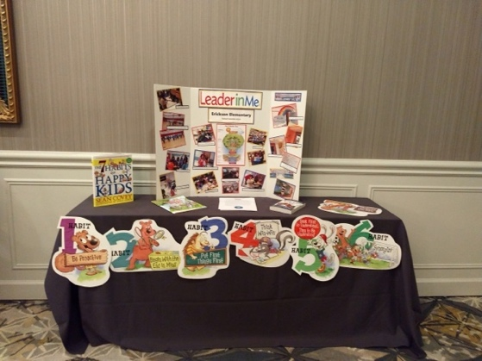
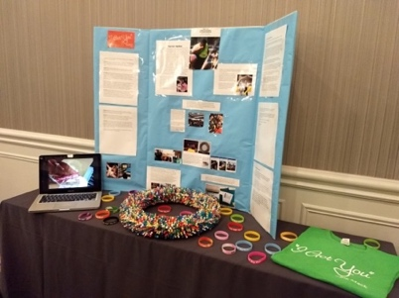
Carpenter Elementary (Ann Arbor) –
I Got You!
Erickson Elementary (Ypsilanti) –
The Leader in Me

