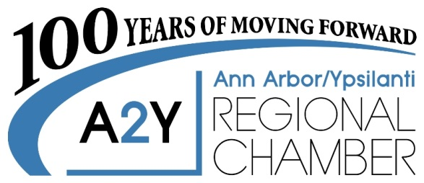
2010 Hogback Rd., Suite 4 | Ann Arbor, MI 48105
P 734-665-4433 | F 734-665-4191 | a2ychamber.org

Two Opportunities to Showcase District Success!

January 2019

Dear Educator and/or Education Advocate,

The Ann Arbor / Ypsilanti Regional Chamber maintains a strong commitment to promoting and recognizing educational excellence in Washtenaw County public school districts. For over two decades, the Chamber has hosted the Exemplary Educational Endeavors Awards (E³ Awards), and the LaFontaine Teacher of the Year award was added to the program to recognize exceptional teachers.

The E³ Awards
The Chamber invites you to put the spotlight on programs that are engaging students on a creative and effective level by submitting a nomination for an E³ Award. Nominations are now being accepted for eligible programs in Ypsilanti, Lincoln, and Ann Arbor area public schools. Other Washtenaw County school districts may also nominate their programs for recognition under the Out-County category. The recipients of the E³ Program Award will receive a trophy and a cash prize generously donated by a local sponsor and the A2Y Chamber’s Education Foundation.

2019 LaFontaine Teacher of the Year Award
District stakeholders will want to nominate outstanding classroom teachers for this award, sponsored by the LaFontaine Automotive Group. The first-place winner will receive a 2-year lease or a $5,000 cash award; the second-place winner (Distinguished Teacher) will receive a $1,000* cash award, and the third-place winner (Commendable Teacher) a $500* cash award.

Multiple nominations from the same school or district are encouraged. The deadline for accepting nominations is 4:30 pm, Thursday, February 21, 2019. The nomination forms are included with this letter for both the E³ Program Awards and the 2019 LaFontaine Teacher of the Year, and can also be found on the Chamber website: www.a2ychamber.org. Examples of nominations are also available on the Chamber website. The preferred method of submission of nominations is by email (a pdf version may be sent to barbara@a2ychamber.org). For additional information or questions regarding this program, please contact Barbara Davenport at (734) 214-0104.

The awards will be presented at the A2Y Chamber’s Early Edition Breakfast on April 17, 2019, at Weber’s Inn, Ann Arbor. We appreciate your assistance in recognizing and celebrating our community’s outstanding teachers, educational programs, and future workforce!

Sincerely,

Diane Keller, President/CEO
Ann Arbor/Ypsilanti Regional Chamber

* Awards will be made payable to the school/district where the nominated educator is teaching during the 2018-19 school year. Award funds must be used for educational purposes or project supplies within the classroom.

