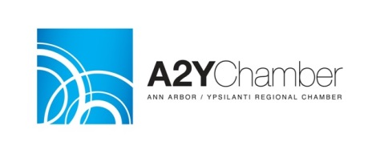

10/27/2014
After deliberations by the Ann Arbor / Ypsilanti (A2Y) Regional Chamber’s Public Policy Committee and Executive Board, the A2Y Chamber has issued the following statement of support for the Ann Arbor Public Schools-Whitmore Lake Public Schools annexation proposal
on the November 4, 2014 ballot:
“Voters in the Ann Arbor Public Schools (AAPS) and Whitmore Lake Public Schools districts should support the annexation proposal on November 4th. Despite awkward ballot language, this proposal is worthy of support because it maximizes the chances for students in both districts to further succeed in the AAPS district. Annexation provides an opportunity to grow funding for students in both districts under the unique annexation language in Michigan’s education funding framework, which would result in almost $1.8 million in additional state support for the combined district. At its heart, annexation will enable AAPS to take in new students in a way that maximizes their funding, while avoiding having to take in those same students under far less desirable circumstances if Whitmore Lake Public Schools falls into financial distress and ultimate dissolution. Annexation will raise taxes for AAPS residents and businesses, but modestly (0.25 and 0.3 mills respectively). The benefits from those increases will be more dollars spent in the classroom and the opportunity for AAPS to grow programs and capacity rather than face cuts. This in turn will help ensure our community can attract and keep the best talent with a world class school system. Annexation offers short term sacrifice for long term gain. The business community and the community as a whole should support this proposal on November 4th.”
For more information contact Andy LaBarre at (734) 214-0101.

